Instructions for Accessing CITI Program Training for the 1st Time

Please note if you already have a CITI account from another institution, use the instructions on the next page
- Navigate to https://about.citiprogram.org/en/homepage/
- Click ‘Register’
- Under ‘Select Your Organization Affiliation’, begin typing Idaho College of Osteopathic Medicine. When the institution’s name appears, select it
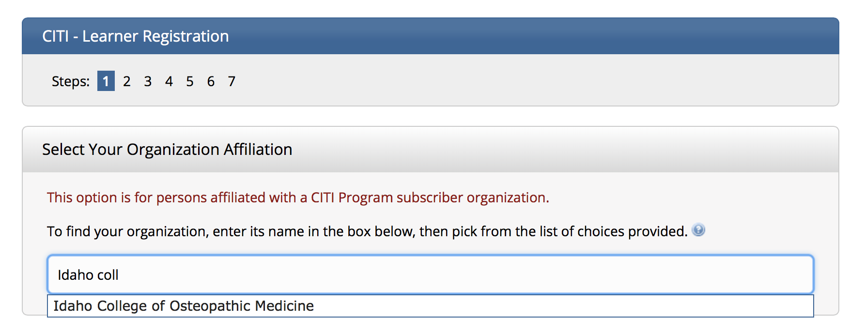
- Click both checkboxes that appear and then ‘Continue to Create Your CITI Program Username/Password’
- Type your name and email address and click ‘Continue to Step 3’
- Create a username, password, and security answer and then click ‘Continue to Step 4’
- Complete Step 4 according to your personal preferences and then click ‘Continue to Step 5’
- Complete Step 5 according to your personal preferences and then click ‘Continue to Step 6’
- Add your email address, department, and role in research and then click ‘Continue to Step 7’
- Request training by clicking on the checkboxes applicable to your role. See the Required Training document for further information. If you aren’t sure which courses to select, move on to the next step and email jlewis@idahocom.org (lab access) or tcoffey@idahocom.org (all other requests) or and ask to be assigned the appropriate training.
- Click ‘Complete Registration’.

Instructions for Transferring CITI Training at Affiliated with Another Institution to ICOM
- Login to your previous CITI account
- Follow the instructions described at this webpage: https://support.citiprogram.org/s/article/how-to-add-change-your-affiliated-institution-or-transfer-completions?_ga=2.109614405.1397570792.1589923865-1892507726.1588804095
- If you training was completed within 3 years at another institution it should automatically transfer to ICOM.

